Name

Date
Period

MyPlate Webquest

Directions: This Webquest will help you experience the United States government’s new MyPlate site. You will learn about the different parts of MyPlate and how they can help you make healthy lifestyle choices. Follow the directions below and write your answers on this sheet.

1. Open QR Scanner app and scan the code at the top of this sheet to enter the MyPlate site.
a. If scanner does not work, you can also select “Chrome” web browser on your Surface and enter
www.choosemyplate.gov in the browser’s search box.

2. Click on “Supertracker and Other Tools” from the green bar at the top of the page. Click on the blue “Daily Food Plan” link. Click on “Daily Food Plan” (blue link) from this new page, under the pink title text. Enter your age, weight, height, and activity level to get personalized MyPlate recommendations. (This information will not be shared with anyone)

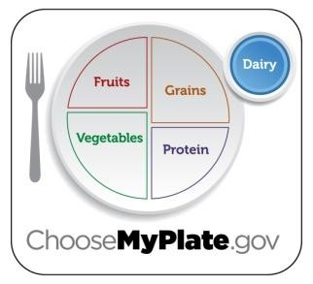
Food Group | Recommended Amount
Fruits
Vegetables
Grains
Protein
Dairy

3. Select “MyPlate” from the green bar at the top of the page. Click on each food group from the left side of the screen in order to learn more and answer the following food group questions. Note: Some answers may be found in the sub-headings within each food group.

Fruits

a) Key Consumer Message:

b) Any fruit or 100% fruit juice counts as part of the fruit group. Fruits can be

, , , or dried, and may be , , or pureed.

c) What counts as a cup of fruit?

cup fresh fruit or 100% fruit juice or cup dried fruit

d) List four foods in the fruits group: , ,

, .
Vegetables
a) Any vegetable or 100% vegetable juice counts as a member of the veggie group. b) Vegetables may be raw or cooked; , ,
, or /dehydrated, and may be whole cut-up, or mashed.
c) Vegetables are organized into 5 subgroups based on their colors and therefore nutrient content. They are:

Group Name | 2 Food Examples in this Group

d) Identify one vegetable that you’ve never heard of before and would like to try:

Grains

a) Key Consumer Message:

b) What counts as an ounce serving? In general, a of bread,

of ready-to-eat cereal, or cup of cooked rice, cooked pasta, or cooked cereal can be considered as a serving from the grains group.

c) Grains are divided into 2 subgroups:

Group | Example of a Food in this Group

Protein

a) All foods made from: , ,

, beans and , , processed soy products, nuts and are good sources of protein.

b) Vegetarians Choices: Vegetarians can get enough protein from this group as long as:

Examples of vegetarian sources of protein are: and

.

Dairy
a) Key Consumer Message:

b) All milk products and many foods made from milk.
c) Calcium-fortified milk is also part of this group, and a good choice for vegans. d) List 5 examples of dairy foods: , ,
, , .

Oils
a) What are oils?

b) Why are oils included in the USDA food patterns?

c) List 3 foods that are naturally high in oils: ,

Click back on “ Food Groups Ove rvi e w” and s ele ct “Empty C alorie s ” fr om “rel ate d topics .”

a) What are empty calories?

b) List 4 foods that are high in empty calories: _ ,

, , and .
Part 2: Health Benefits

What can the MyPlate Groups do for my body, and how can I get more?

“An apple a day keeps the doctor away…” - Anonymous

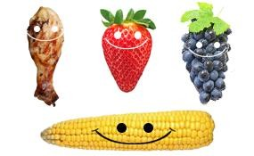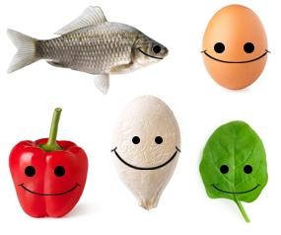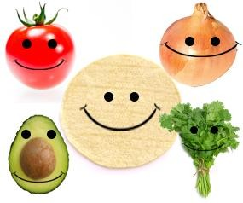

Fruits

c) How can eating fruits benefit your health?

i.

ii.

d) Paraphrase 2 tips to help you eat more fruits:

i.

ii.

Vegetables

a) How can eating vegetables benefit your health?

i.

ii.

b) Based on our class discussion and the definition of “variety,” explain how you can get more

“variety” in your vegetable choices?

c) Paraphrase 2 tips to help you eat more vegetables:

i.

ii.
Grains

a) Why are grains refined?

b) When the bran and germ are removed in refining, what else is removed?

, , and many

.

c) Scan the QR code on the left and record definition “d” for the vocabulary word fortify:

d) Paraphrase 2 tips to help you eat more whole grains:

i.

ii.

Protein

a) Paraphrase 3 tips to help you make wise, lean protein choices:

i.

ii.

iii.

Dairy

a) Give 2 selection tips for dairy foods:

_
Part 3: SuperTracker

To see how what you have eaten meets your MyPlate needs, you will need to create a SuperTracker profile. You can use this username and password to go back to your information at home or any time.

Scan the following code to launch the SuperTracker:
https://www.supertracker.usda.gov/

Creating a Profile:
1. Click on the “Create a Profile” link.
2. Type in a profile name: FACS-YourInitials (ex. FACS_ET)
2. Fill in age, gender, and physical activity level.
3. Enter height and weight (optional).
4. Scroll down to register.
5. Enter a username. Write your username here:

6. Enter a password. Write your password here:
7. Answer the password hint.
8. Select and answer the security question.
9. DO NOT enter an email address.

Entering food into your tracker:
1. Click on “Track food and Activity” from the blue bar at the top of the page.
2. Enter the first food from your “diet recall” list in the “type food here” box and click “go.”
3. A list of foods will pop up, click on the best choice for what you ate.
4. Choose a mealtime (breakfast, lunch, dinner, snack) by checking the correct box.
5. Click “add” to add the food to your tracker. You should see your daily food targets and graph
change.
6. Repeat steps 2-5 to add all the foods from your recall.
7. When finished, use your information to fill in the chart and graph below:

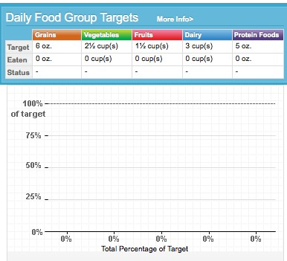
Part 4: I’m Through, What do I Do?

If you have finished early, use your Surface to explore the questions below!

1. Physical Activity
a) List 2 moderate physical activities: and .
b) List 2 vigorous physical activities: and . c) Why is physical activity important? Explain in a 2-3 sentence paragraph.

2. Explore the “Healthy Eating Tips” Tab. Pick 1 topic, and list 5 suggestions here:

Topic:

1.

2.

3.

4.

5.

3. Kids Health.com also has great nutrition information for preteens and teenagers. Scan this code and explore the “Fabulous Food” and “Eat Like a Pro” sections. Choose one article and summarize it below using 2-4 FACS vocabulary words. Continue on the back of this sheet if needed.

