________________________________________________________________________________________________________________________________________________________________________
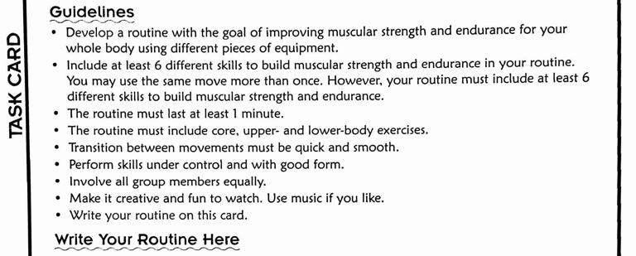
Skill or Transition | Count | Skill or Transition | Count
1. |  | 8.
2. |  | 9.
3. |  | 10.
4. |  | 11.
5. |  | 12.
6. |  | 13.
7. |  | 14.

